PART A: Participant Information

Participant Full Name
Gender | Male ☐ Female ☐
NDIS Number  Plan start & End Date  NDIS GOALS | Please send us NDIS goals with this referral form
Date of Birth
Contact Number
Email
Residential Address

PART B: Support Person/ Parent Details (if participant below 18 years of age)
Full Name of support Person
Relationship to Participant
Contact Number & Email

PART C: NDIS Plan Details
Plan Management | Self-managed ☐ Agency-managed ☐ Plan-managed ☐
If plan-managed, Company
Contact Number & Email

PART D: Capacity Building Funding
Capacity Building- Improved Relationship funding approved in their plan? | Yes ☐ No ☐
If yes, please provide details of allocated funding | Total funds for behaviour support: $  Allocated funds for 11_022_0110_7_3: $  Allocated funds for 11_023_0110_7_3: $  Allocated funds for 11_024_0110_7_3: $
If no CB funding, please provide details of funding to be utilised for this support

PART E: Support Coordinator/Referrer Details
Full Name of Person
Relationship to Participant
Contact Number & Email
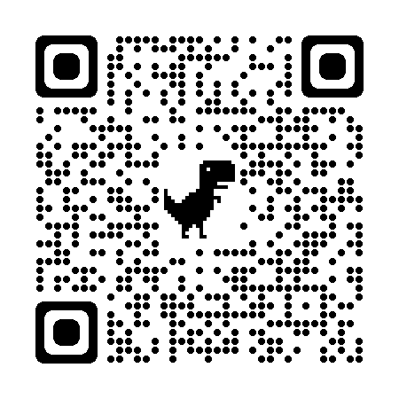
NOTE: Please forward the completed referral form to enquiries@towardsthehorizon.com.au OR emma.oneill@towardsthehorizon.com.au
For any additional information, please ring office directly on +61498 544 046 OR +61 481 211 600

Towards the Horizon provides Behaviour Support Services in
Darwin, Katherine & Alice Springs
https://towardsthehorizon.com.au/
https://www.facebook.com/towardsthehorizen.com.au
https://www.instagram.com/towardsthehorizon.com.au/

